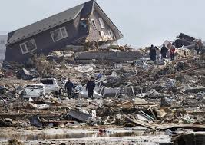 FAKE NEWS 2

WASHINGTON, DC — A magnitude 7.8 earthquake has left thousands injured in Washington, DC. According to officials, the supersonic boom was man-made.

Washington, DC residents are distraught as they try to recover what's left of their homes and locate their families.

While earthquakes may be somewhat frequent in Washington, DC, this was no ordinary earthquake.